Solution Document

# 1. Architecture

In order to implement the above solution, the microservices way, we identify four different modules to decouple the monolith. These four modules are:

1. UI module,
2. Authentication Module,
3. Products Module and
4. Payment Module

These are put in the component diagram as below:

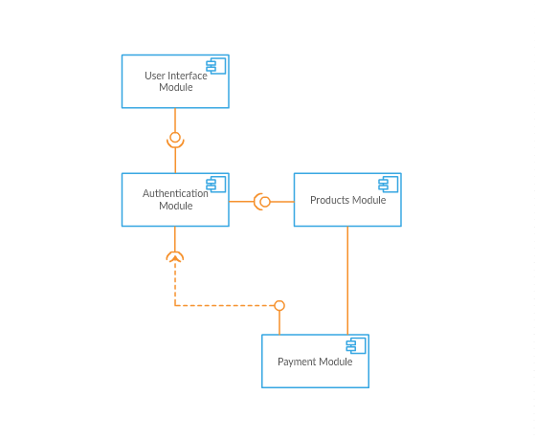

## UI Module

This module will mainly be responsible for creating an amazing user experience as we showcase them our mainstream products. This independent module will essentially consist of all necessary content that will be available to all users through the internet. Since our target is an e-commerce application, following is a mock up wireframe of how it will look (ekart is a hypothetical name here and it bears no resemblance☺)

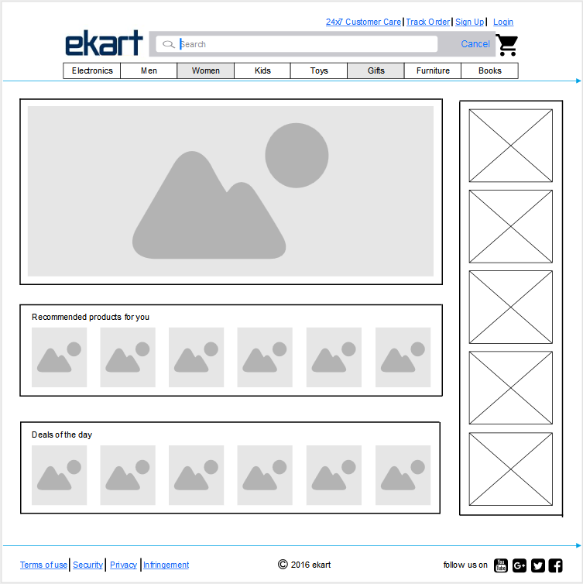

Here all products will be visible to users irrespective of whether he/she is a registered user or not.

## Authentication/Authorization Module

This module essentially deals with validating a user and showing him/her the content based on relevant authorizations

## Products Module

This is a module which in reality stores all necessary product data. We can think of it as a content management system which periodically indexes product data which will be used by the UI module to populate the wireframe as shown above.

## Payment Module

As the name suggests, this will be the most important module which will mark transaction boundaries for any users as it deals with real monetary transactions with help from various payment gateway service providers.

# 2. Diagrams

## 2.1 Use-case diagram

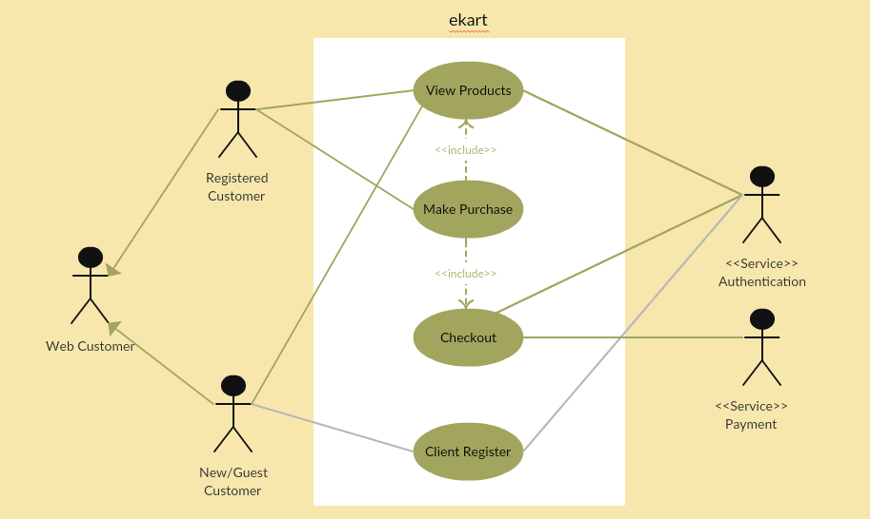

## 2.2 E-R diagram

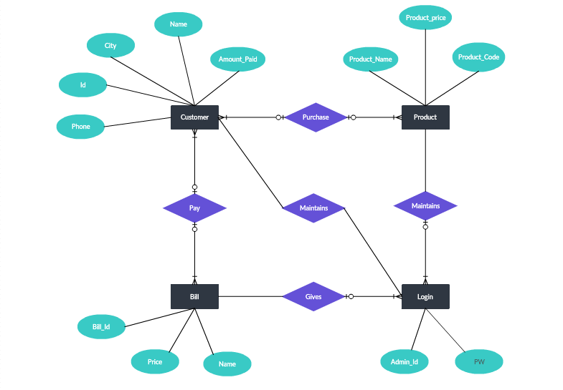

## 2.3 Class diagram

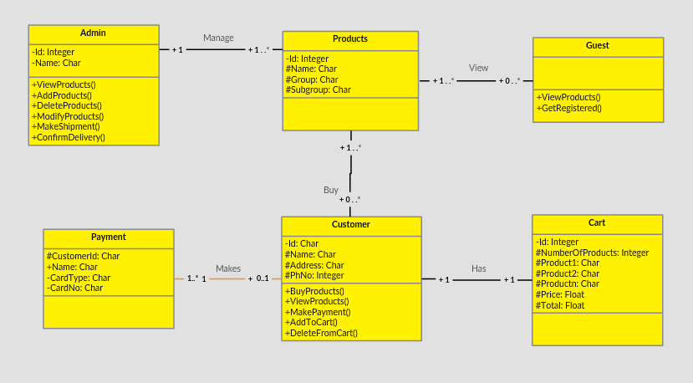

## 2.4 Sequence diagram

